Overview:
The NC Main Street & Rural Planning Center is proud to annually recognize the efforts of dedicated individuals who have contributed to the success of the local programs across our state. A non-competitive award, the NC Main Street Champion designation honors those persons who have made extraordinary contributions to their downtown. The NC Main Street & Rural Planning Center will individually recognize Champions with a video presentation and commemorative certificates celebrating this special honor during the Annual NC Main Street Conference.

Entry Deadline:
- September 30, 2022 | 5pm

Awards Ceremony:
- March 16, 2023 | Statesville

Who is Eligible to Nominate a Champion?
- Only communities that are a designated NC Main Street community are eligible to nominate a Champion.
- DAC and Small-Town Main Street communities may nominate once they move up to NC Main Street
Why Nominate?
Designating an NC Main Street Champion is a wonderful way to show your organization’s appreciation for the efforts of a deserving person (or persons) who has/have gone the extra mile in working to make your downtown successful. A secondary benefit of designating a Champion is the opportunity it provides for generating goodwill and positive PR for your downtown program.
What Makes Someone Eligible for This High Honor?
NC Main Street Champions MUST BE PEOPLE, who have made a SIGNIFICANT impact in your downtown or your downtown program, ideally over the last year and who went above and beyond their volunteer or job responsibilities. Once an NC Main Street Champion, always an NC Main Street Champion! If your program has previously honored someone as an NC Main Street Champion, that individual continues to be a Champion for your community and may not be re-designated by your program. However, someone who received the designation from another community and has made significant contributions to your downtown’s revitalization efforts may also be named a Champion by your program.

Champion designation may fall under the following categories:
- An individual John Smith
- A couple Jane and Lucy Smith
- A civic organization board of directors Board of Directors Ayden Arts Council
- Owners of a downtown business John Smith
- Owners of a property John Smith
- Governmental council Board of Commissioners, Town of Smallville
- Departmental staff Public Works Staff, Town of Smallville

Champion nominations ARE NOT:
- A municipal entity Town of Smallville
- A business Nil’s Cafe
- Staff of a business Nil’s Café and Staff

Instructions
Please use the following pages to draft, edit, and proof your nomination.
- Text may not exceed 200 words
- Text must be in narrative style – no bullet points
- Text should include only information directly related to the Champion’s contributions to downtown. * Information on family, civic involvements or religious affiliation is not relevant to this designation
- Text should provide enough detail to give a real sense of your Champion and his/her/their contributions to downtown
- Have someone to proofread your submission for content, grammar, and spelling before submitting online.
- HARD COPIES WILL NOT BE ACCEPTED
- The NC Main Street & Rural Planning Center reserves the right to edit the narrative text for length and content.
Nomination Photo
Please consider using a local photographer for your Champion’s headshot. Remember that these photos will be on our NC Main Street Conference website. Make it your best shot.
Photos must:
- Be 1024 x 768 pixels with a file size of at least 1MB or higher. (Not checking the pixels will cause additional steps for you, so please make sure you have checked them prior to sending the image in.)
- Be taken in good lighting. If taking a photograph outside, make sure the photographer’s back is to the sun.
- Be cognizant about the background you use for the photo.
- Be of ONLY the Champion(s). We cannot accept images that include any person(s) other than the Champion(s). Do not crop a photo so that only the champion(s) is showing.
- Be free of borders, labeling or date stamps.
- Not be altered with Photoshop

Submission
Use the space below to prepare your submission. You will copy and paste this information onto the online form.
Town Name: Note: Do not use "Town of" or "City of" when entering the name
Write Text Here
Champion’s Name: Note: Please provide the official name that will be printed on the certificate
Write Text Here
Champion’s Email: Note: We will NOT contact them via email unless we have questions about their conference registration for the Champion Ceremony. The Director will be emailed the Champion letter and will then forward or present that letter PRIVATELY to the Champion prior to the conference.
Write Text Here
Champion’s Mailing Address:
Write Text Here
Director’s Name:
Write Text Here
Director’s Email:
Write Text Here

Nomination Submission:
Note: Please write the nomination text for your Champion. Remember to include why they have made a SIGNIFICANT impact in your downtown. This honor goes to individuals who have gone above and beyond their volunteer role or duties. Text Maximum Limit: 200 words or less
Samples: Please refer to previous year Champion Submissions to assist you in preparing your submission. https://www.ncmainstreetandplanning.com/ncmainstreetchampions
Write Text Here

On Behalf of Name:
Note: Please provide the official name that will be printed on the certificate.
Sample: Smallville Development Corporation OR City of Smallville OR Smallville Main Street Program, etc.
Write Text Here

Photo Upload:
- Check Your Photo Resolution: Must be1024 x 768 pixels with a file size of at least 1MB or higher.
- Save Your Photo: Include Town/City Name, Champion Name
Sample: Garner_John Doe
Edenton_Jane Doe
Lenoir_Jill Doe
- Upload Your Photo Online

Signature:
Hit Submit Button!

FAQ:
Did it go through?
Note: If your submission was processed you will see the responder message below.
IMPORTANT: The #1 reason why people do not get this message is because they did not upload a high-resolution image, based on the file size noted above. If you keep clicking the submit button and don’t get the message below, check your image size, and look for anything highlighted in red on the form.
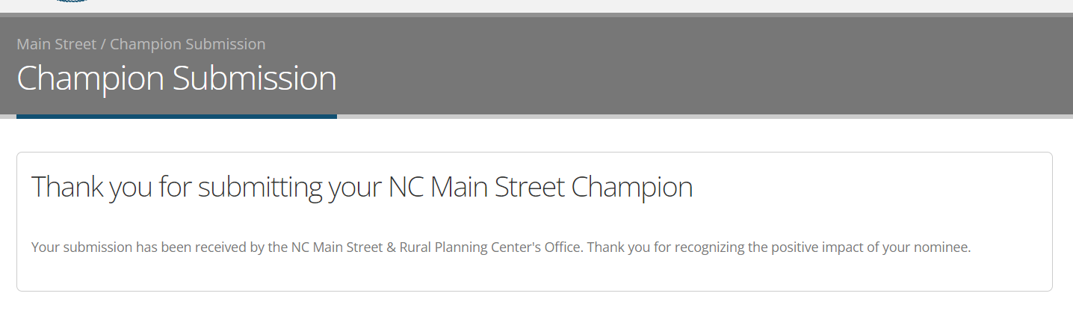
Can I have a copy of my submission?
Note: After your submission, you will receive an email with a pdf of the submission. Please download and save the submission. The email will look like the image below. 