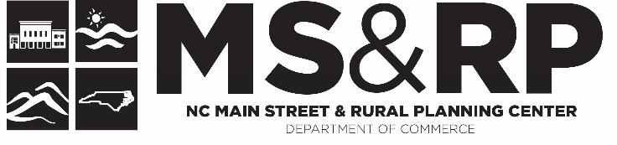

How Do You Use Your Info to Tell Your Story?
Ideas Generated at the N.C. Main Street Directors Meeting – August 3-5, 2022, Elizabeth City

Main Street communities are part of a national network with a proven record for generating strong economic returns and strengthening the district’s position within a highly competitive marketplace. Standard Six highlights the importance of tracking, packaging, and demonstrating the qualitative and quantitative impact of the program’s revitalization efforts. It also provides the opportunity for the local Main Street program to tell their stories and advocate for resources needed for sustainability.

As a group, brainstorm how you will tell your story, using a mix of tools, for the following scenarios. Tell your story visually, orally, and numerically. Use traditional and nontraditional methods to reach a broad audience.
If you don’t tell your story, someone else will!

The Main Street program is a national movement led by the National Main Street Center at the national level, the NC Main Street & Rural Planning Center in the Department of Commerce here in North Carolina, and by your organization at the local level. How would you tell the impact of your community’s experience as a Main Street community?

Your community is experiencing a milestone year in 2023. (35 years for Burlington, Elizabeth City, Lumberton, Mooresville, Mount Airy) (30 years for Albemarle, Boone, Brevard, Lexington) (25 years for Elkin, Monroe, Oxford) (20 years for Eden, Edenton, Forest City, Marion) (5 years for Elon, Laurinburg) How will you celebrate and communicate the impact of the program?

Every community has unique local assets that are used to develop transformational economic development strategies for growth and investment. How will you communicate the importance or your local assets and how they are transforming your downtown?

Your community experienced one of these scenarios. How will you tell your story?
- The largest amount of investment in a single year.
- The greatest number of building rehabilitations every experienced.
- The largest number of volunteer hours ever contributed to the organization and the value of that investment.
- A white elephant building (theater, hotel, furniture store, department store, etc.) was rehabilitated.
- New residents moved downtown and now call the district home.
- New businesses opened their doors and expanded the goods and services offered in downtown.

