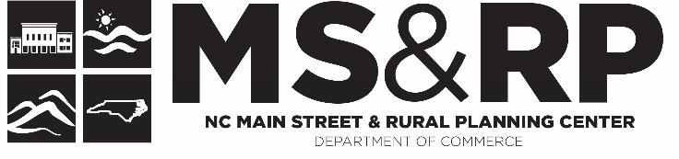

Transforming Downtown Through a Plan
Worksheet used at the N.C. Main Street Directors Meeting – August 3-5, 2022, Elizabeth City

Main Street has built a strong track record for making change happen in communities across the country. Change is an important guiding principle for Main Street. But rather than letting change just happen, Main Street programs define and manage it from one year to the next through a strategy-driven work plan and aligned implementation process. Standard Four brings together all integrated components that must be in place to plan and successfully implement the revitalization work. Centered around Main Street’s Four Point Approach, these integrated components are driven by a local Transformation Strategy(s) aligned through community participation and based on understanding of the district’s unique and competitive market position.

Instructions for your group:
1 - Select one economic development strategy. (Transformation Strategy)
2 - Develop a broad goal for the strategy and a measurable objective.
3 - Then develop measurable actions that will be implemented through the Main Street Four Points™.

Definitions:
Economic Development Strategies (Transformation Strategy): Strategies are defined in your vision statement that will transform your downtown into a more economically vibrant district.
Goals: What are you trying to achieve with your strategies? Goals are broad, general, abstract
Objective: For what purpose? Why are you trying to achieve your goal? To …. Objectives are precise, tangible concrete and measurable
Actions: How are you going to achieve each goal and objective? – What is the organization’s plan for accomplishing each goal and objective? Economic Vitality, Design, Promotion, Organization.
Measures: A number, a timeframe, or a percentage.
Example:
Strategy: To be the hub of life-long learning and education for the region.
Goal: Offer life-long learning opportunities in downtown for retired adults.
Objective: Increase the retiree consumer market by 150 weekly downtown visitors.
Economic Vitality Action: Recruit a community college satellite operation to dt. by December 2022 and offer 10 life-long learning opportunities a week at the facility.
Design Action: Partner with the City to make improvements by June 2023 to the West Avenue public parking lot and promote the lot as free parking for retirees on the promotional materials.
Promotion Action: Offer Wine-Down Wednesdays in downtown for Seniors during the fall, 2022.
Organization Action: Partner with 3 agencies by January 1, 2023, that work with retirees to survey interest in life-long learning and their needs, in regard to downtown.
Strategies to choose from:

- The center of Arts & Culture for downtown.
- The hub of our Agricultural Economy.
- The center of Apparel Goods and Services.
- The center of Education and Life-long Learning.
- Offering first class College-Town amenities.
- Crossroads to exceptional Outdoor Recreation.
- The location of choice for convenience goods and services.
- The hub of Dining and Entertainment.
- Providing world-class amenities for Downtown Workers and Residents.
- An Elder Friendly downtown that offers Aging in Place Services.
- Offering Ethnic Specialties for the region.
- Serving Families in a Friendly Environment.
- Offering the best selection of Food and Spirits.
- The hub of Green Products and Services.
- The center of Health & Wellness.
- The largest collection of Home Furnishings.
- Building a Knowledge Economy.
- Providing Small Scale Manufacturing opportunities.
- Providing amenities for Military Families.
- The location of choice for Millennials.
- The trailhead of Sports & Recreation.
- Attracting the Creative Class to downtown.
- The hub of Corporate Headquarters.
- Exceptional Urban Living.
- The largest collection of Locally Owned Businesses.

