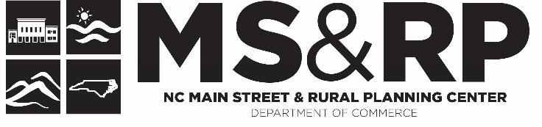

How to Develop Volunteers for your N.C. Main Street Program
Ideas Generated at the N.C. Main Street Directors Meeting – August 3-5, 2022, Elizabeth City

Strong, thriving communities don’t just happen. They need effective leaders at all levels, from a broad base of committed volunteers to dedicated professional staff offering their time, talents, and passion for this work. Standard Two reflects the value we place on PEOPLE as Main Street’s greatest resource and our belief that everyone in the community has a place in Main Street. This Standard encourages Main Street programs to place a strong priority on human capital and develop a clear operational structure and practices that increase the organization’s capacity to engage all sectors of the community and leverage their participation in their revitalization efforts.

As a group, brainstorm how you will recruit a broad mix of staff, committees, and volunteers to be more inclusive:
“The leadership base should be open, inclusive, and representative of the entire community, taking into account abroad range of dimensions of diversity, including race, ethnicity, gender, education, physical and mental ability, veteran status, and income level. The program should take proactive measures to ensure under-represented groups are included as part of Main Street’s leadership base.”

As a group, brainstorm how you improve the way you train your volunteers:

As a group, brainstorm how you improve the way you manage your volunteers:

As a group, brainstorm how you improve the way you celebrate your volunteers:

